Impact of EU CO2 trading scheme on energy sector

*The comparison of Austria and Czech Republic*

Tomáš Smejkal

Teresa Kallsperger





Prague and Graz, 2011

Content

Problem statement 3

Abstract 3

1. Brief introduction of EU emission trading scheme 4

1.1 Situation in Austria 5

2.1 Situation in Czech Republic 9

2. Comparison of energy mix inCzech Republicand Austria 10

3. Windfall profits as an impact of carbon trading 14

4. Cost pass through 19

5. Conclusion 24

# **Problem statement**

Facing the world wide problem of climate change caused primarily but among other things by rising emissions, communities of states are challenged to find adequate solutions. Emissions shall be reduced on the one hand, but on the other hand economic stability shall not be endangered. The reduction of emissions is traced back to the causative principle: the ones that cause the emissions, have to take responsibility for them or in other words have either to reduce the emissions or compensate them monetarily.

In 1997, the Kyoto Protocol was ratified as the first obligatory treaty trying to combat global warming. Providing opportunities being able to attain the reduction targets, the EU launched the EU Emission Trading Scheme in 2005, which shall give a tool for each member state to being able to trade green house gas emission. The trade emphasizes on carbon, as it is not the most harmful green house gas, but it`s the most measurable one. Having had the testing phase of period one from 2005 - 2007 and being currently at period two, some countries didn`t match up with the asked targets so far to reduce their emission, which is illustrated in *figure1*:

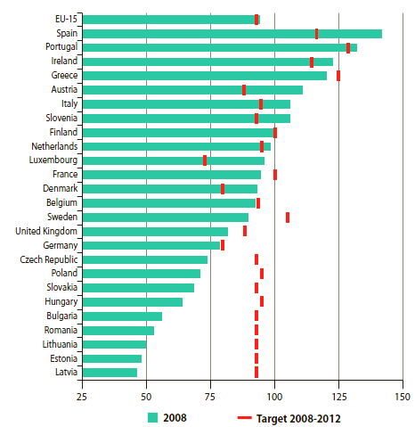

*Figure 1*: Index of green house emissions in 2008 from the base year and agreed reduction targets according to the Kyoto Protocol for 2008-2012

# **Abstract**

The Energy sector is, as a major eminent of CO2, highly influenced by EU ETS program. In this study we want to primarily focus on climate policy impact on energy market with special concern on electricity market and examine how emission trading influences these particular markets. The analysis will be based on comparison between Austria and Czech Republic with special focus on differences in trading scheme assessed by national government and especially on different impacts of trading schemes in countries with diverse energy mix. We will further address how emitters in each state transmit allowance price to price of electric energy and consequently discus windfall profits caused by trading system. Final part will deal with cost pass through rate. We will then conclude and highlight the main differences among chosen states.

## **Brief introduction of EU emission trading scheme**

Facing the mandatory reductions of minus eight percent of green house gases, which were determined by the Kyoto Protocol in 1997 for the period after 2008, the EU developed the EU Emission Trading Scheme (EU ETS) to achieve the reductive aims. The EU ETS was introduced to give a framework for trading opportunities for green house gases. Outbound from the country specific reduction targets, which can be seen in *Figure 1*: *ETS allowances per country 2005-2012* (in appendix) exact amount of green house gases, that has to be reduced per period is determined for each country, and consequently distributed to the concerned sectors and consequently to the concerned companies, which is set down in the National Allocation Plans (NAP). The NAPs have to be approved by the EU and are the basis for the trading, as they show which company is allowed to emit which amount of emissions and how many certificates are distributed in the particular country.

One basic aim of the EU ETS was to create an artificial market for trading carbon. Therefore carbon is used as a scarce good, which is consequently traded. The most common currency is one emission allowance (EUA). It enables to emit one tone on carbon (*EU ETS, 2008*). Besides, there is the Certified Emission Reduction (CER) and the Emission Reduction Unit (ERU), which are some credit advices in emitting carbon. Those are used to reduce carbon within projects mostly with other countries, like part of the Kyoto specifics Joint Implementation or Clean Development Mechanism (*EU ETS, 2008*).

If companies emit more green house gases than their certificates allow them to, they have several options: Firstly, they can limit their production and consequently reduce their emissions. Secondly, they can change their technology, like use the best technology available at the moment or change the material and make it more environmental friendly. Thirdly, they can buy more certificates, that gives them the right to emit more. Because of economic dynamics, a market price will develop, determined by supply and demand.

The EU ETS is constructed for three periods: The first one for 2005- 2007, the second one for 2008-2012 and the third one for the period after 2013: The first period was seen as a testing phase to gain some experience within trading emissions and 95 % of certificates had to be allocated for free and the rest could be distributed by auctioning. But most of the countries distributed all of them for free. Because of that, certificates that weren`t used in the first phase couldn`t be transferred to the second period. In the second current period, in which the Kyoto targets are mandatory, 90 % of certificates have to be allocated for free and the rest can be allocated individually by the particular countries. From 2013 on, the National Allocation Plans won`t be used anymore to determine the allowed amount of emissions, but there will be a general EU allocation plan and the distribution will emphasize more on auctioning. (*Gilbertson & Reyes 2010*) Moreover, flight traffic will be included in the EU ETS, which wasn`t concerned by emission restrictions so far (*EU ETS, 2008*).

The EU ETS started with its member states and additionally countries like Norway, Lichtenstein and Iceland. At the moment about 11 000 factories and refineries of the power generation and manufacturing sector are included (*EU ETS, 2008*), which belong to the industries of energy, paper, cement, mining and oil. Companies are enabled to trade their certificates directly with others or by stock exchange, but those possibilities vary by country.

There are several aspects of viewing the EU ETS in a critical way: Generally the question arises, whether the obligatory reduction targets are fair, as they emerged from the Kyoto negotiations and consequently have to do with the power of particular countries and their willingness to participate in mechanics as the EU ETS. After the ending of the first period it could be seen, that too many certificates were on the market and thus companies didn`t have much motivation to reduce their emissions. As the first period wasn`t included in the Kyoto Protocol the reduction targets weren`t obligatory. In the second period, the numbers of certificates, which are available for the market was reduced. Moreover one might ask, whether the additional costs for the certificates, which haven`t existed in the past, are transferred to the customers by higher prices, instead of being borne by the producers. Especially in the electricity sector, where the demand is pretty inelastic, it is probable that customers have to afford higher prices because of the emission certificates. This aspect will be discussed more detailed later on. Another critical aspect arises in regard to higher profits for the companies. As they estimate the future prices for emissions and implement those estimations in their calculations, higher profits might arise.

### Situation in Austria

The law of emission certificates (EZG) is the official basis for trading green house gases and especially carbon in Austria. It was published in 2004 and was proclaimed to be the first tool to connect aspects of environmental protection with market based mechanics in Austria ([*Federal*](http://www.dict.cc/englisch-deutsch/Federal.html)[*Ministry*](http://www.dict.cc/englisch-deutsch/Ministry.html)[*of*](http://www.dict.cc/englisch-deutsch/of.html)[*Agriculture,*](http://www.dict.cc/englisch-deutsch/Agriculture.html)[*Forestry,*](http://www.dict.cc/englisch-deutsch/Forestry.html)[*Environment*](http://www.dict.cc/englisch-deutsch/Environment.html)[*and*](http://www.dict.cc/englisch-deutsch/and.html)[*Water*](http://www.dict.cc/englisch-deutsch/Water.html)[*Management*](http://www.dict.cc/englisch-deutsch/Management.html) *Austria, 2004*). It was developed due to the obligatory emission reductions of the Kyoto Protocol and the hence released EU guideline 2003/87/EG about trading with emission certificates. According to the Kyoto Protocol, Austria has to reduce its green house gases about 13 % compared to the base year of 1990. But concerning the previous development and the current predictions, Austria will fail enormously. The most important aim of the EZG is to create a system to be able to trade green house emissions and consequently to reduce those green house gases (*List, 2009*).

One basic requirement to participate in the emission trading is the ability of productive institutions to monitor and to document the amount of emissions. Only if this condition is fulfilled, one receives a permission to participate. The law is valid for so called “activities” which include the transformation of energy, the metal production, the mineral processing, and the paper and pulp production. Moreover, the amount of emissions has to be controlled permanently (*List, 2009*).

Furthermore, the EZG indicates the method of distribution of certificates, which is the National Allocation Plan for each period. Generally, several criteria, which are listed in §11 of the EZG are given: Firstly, technical potential has to be considered, like the energy efficiency, predictions about the amount of produced output and so on. Secondly, environmentally friendly technologies like the generation of heat and power or district heating are consulted as well. Another point is that the distribution is consistent with other EU or Austrian political aims, like for example the electricity supply may not be endangered.

The first National Allocation Plan for the period between 2005 and 2007, which was published in 2004 considered the past emissions of the concerned facilities for the period of 1998 to 2001 as well as the reduction potential for the future, which is included in the National Climate Strategy of 2002, to reach the Kyoto targets.

The general target for the first period was to reduce 1,65 mil. tons of carbon for the energy and industry sector ([Federal](http://www.dict.cc/englisch-deutsch/Federal.html) [Ministry](http://www.dict.cc/englisch-deutsch/Ministry.html) [of](http://www.dict.cc/englisch-deutsch/of.html) [Agriculture,](http://www.dict.cc/englisch-deutsch/Agriculture.html) [Forestry,](http://www.dict.cc/englisch-deutsch/Forestry.html) [Environment](http://www.dict.cc/englisch-deutsch/Environment.html) [and](http://www.dict.cc/englisch-deutsch/and.html) [Water](http://www.dict.cc/englisch-deutsch/Water.html) [Management](http://www.dict.cc/englisch-deutsch/Management.html) Austria, 2004) . All in all there were 99 mil. certificates available, which were all allocated for free. From those 99 mil., one percent was kept as a reserve for new market participants. The distribution took place in consideration of sectors, which are energy and industry. All in all there were 32 674 905 allocations of certificates predicted per year, which can be seen in figure 3.

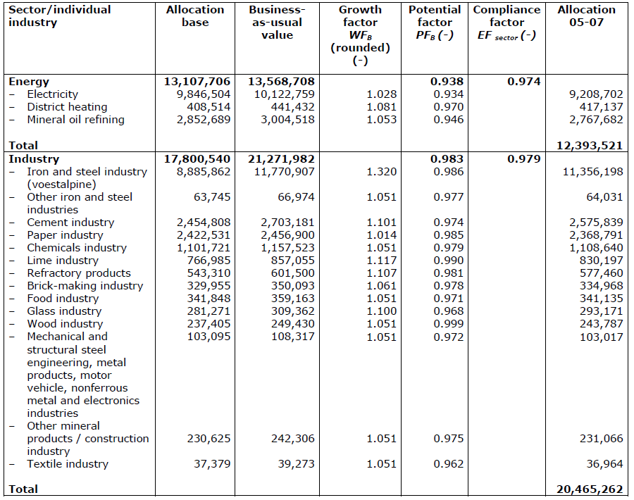

*Figure 2*: Number of allocations p.a.

Most important, the National Allocation Plan gives an exact overview of allocation by company in the annex. Moreover, the EZG adjusts special belongings in a very detailed way, for example the transfer of certificates, the observance of reporting deadlines and so on. The certificates are valid for one period and four months after the ending of one period the certificates lose their value. There is a register for documentation, in which the transmission, the property and the deletion are fixed. The exact calculation of allocations and further details won`t be explained here, as this would go beyond the scope of this discussion.

The second National Allocation Plan for the period between 2008-2012, which was published in 2006 determined a number of 164 mil. certificates being allocated. That`s about 0,55 mil. certificates less per year in comparison to the first period. Same as in the first period, one percent of all certificates was kept as a reserve for new market participants. 98,8 % have to be allocated for free and the rest has to be allocated by auctioning. 5,5 mil. tons of carbon shall be reduced towards the predicted numbers for 2008-2012 without any reductions. The period of 2002-2005 was used as a consideration of carbon emissions of the concerned facilities as base period. The whole paragraph refers to both NAPs of Austria (2004, 2006) as well as to the EZG.

As already mentioned above, most of the certificates were allocated for free in the first two periods. However, there is the [Federal](http://www.dict.cc/englisch-deutsch/Federal.html) [Law](http://www.dict.cc/englisch-deutsch/Law.html) [Gazette](http://www.dict.cc/englisch-deutsch/Gazette.html) about the auctioning of certificates, which says that for the second period 2 000 000 certificates have to be auctioned. The law regulates the formalities and the disincentive of modalities. Basically, 20 % of the sales volume has to be auctioned in a non competitive auction. The auctions are held by Climex, a Dutch exchange organization via Internet. The first auction in Austria took place in march 2009, in which about 100 000 Emission Unit Allowances (EUA) were sold non competitively and 200000 EUAs were sold competitively having started with a minimum price of 7,16 € per tonnes. Since then, five auctions have already taken place, with the last one held on April the 11th (*climex.com*).

Basically, owners of certificates have two options of trading with carbon: Firstly they can trade directly with other holders or secondly they can trade by stock exchange. There are three localities for stock exchange in Europe, which are Amsterdam, Leipzig and Graz. For the Austrian carbon trading, especially the Exaa Graz is important. Nevertheless, participants of stock exchange of certificates are from different countries, which can be seen in *figure 3*:

|  |  |  |
| --- | --- | --- |
| Name of company | Country | Joining date |
| [Advantag AG](http://www.advantag.de) | D | 27.12.2010 |
| [Aitherco2 SRL](http://www.aitherco2.com) | IT | 21.02.2011 |
| [Bergen Energi AS](http://www.bergen-energi.com) | NO | 02.11.2009 |
| [Böning KG](http://www.umweltmagazin.at) | A | 20.08.2008 |
| [Carbon Retirement LTD.](http://www.carbonretirement.com) | UK | 16.06.2008 |
| [citiworks AG](http://www.citiworks.de) | D | 29.01.2010 |
| [e & t Energie Handelsges.m.b.H.](http://www.eundt.at/) | A | 28.06.2005 |
| [EGL AG](http://www.egl.ch/) | CH | 28.06.2005 |
| [Emissionshandelsgesellschaft Michael Pohlmann KG](http://www.emissionshandelsgesellschaft.de) | D | 27.11.2008 |
| [Emissionshändler.com](http://www.emissionshaendler.com/) | D | 15.02.2006 |
| [Energie AG Oberösterreich Trading GmbH](http://www.energieag.at/) | A | 02.11.2006 |
| [ETECH Management GmbH](http://www.etech-consult.at/) | A | 28.06.2005 |
| [Edelweiss Energia S.p.A.](http://www.edelweiss-energia.it/) | IT | 13.05.2008 |
| [Evonik Steag GmbH](http://www.steag.de) | D | 21.11.2006 |
| [FAME Investments AG](http://www.fameinvestments.at) | A | 27.12.2010 |
| [Gallehr Sustainable Risk Management GmbH](http://www.gallehr.de/) | D | 22.04.2008 |
| [Glaswerk Ernstthal](http://www.glaswerk-ernstthal.de/) | D | 07.06.2006 |
| [GEN-I d.o.o.](http://www.gen-i.si/) | SI | 04.05.2006 |
| [INVEKS AS](http://www.jic.lv) | LV | 23.12.2008 |
| [Kelag-Kärntner Elektrizitäts-Aktiengesellschaft](http://www.kelag.at) | A | 16.06.2008 |
| [Keraform Spezialziegel GmbH & Co. KG](http://www.keraform.de/) | D | 22.04.2008 |
| [Linz Strom GmbH](http://www.linzag.at/) | A | 09.09.2005 |
| [MVM-Adwest Marketing und Handels GmbH](http://www.mvm-adwest.at) | A | 16.06.2008 |
| [OeKB Business Services GmbH](http://www.oekb.at/) | A | 09.09.2005 |
| [R.H. Calltrade GmbH](http://www.rh-calltrade.de) | D | 27.12.2010 |
| [RWE Supply & Trading Netherlands B.V.](http://www.rwetrading.com) | NL | 28.06.2006 |
| [Stadtwerke Flensburg GmbH](http://www.stadtwerke-flensburg.de) | D | 19.03.2010 |
| [STEWEAG-STEG GmbH](http://www.steweag-steg.com/) | A | 28.06.2005 |
| [Swarovski & Co.](http://www.swarovski.com/) | A | 28.06.2005 |
| [Swiss Climate Invest AG](http://www.swissclimateinvest.ch) | CH | 20.03.2008 |
| [TIWAG Tiroler Wasserkraftwerke AG](http://www.tiwag.at/) | A | 28.06.2005 |
| [Tondach Gleinstätten AG](http://www.tondach.at/navigation/show.php3?_country=at&_language=de) | A | 28.06.2005 |
| [UMB UmweltManagementBeratung Hacker GmbH](http://www.umb-hacker.de) | D | 25.08.2006 |
| [Verbund AG](http://www.verbund.at) | A | 28.06.2005 |
| [World Energy DE GmbH](http://www.worldenergy-germany.de) | D | 19.03.2010 |
| [Ziegelwerk Blomesche Wildnis Heinrich Pollmann jun. KG](http://www.ziegelwerk-blomesche-wildnis.de) | D | 20.03.2008 |
| [Ziegelwerk Lizzi GmbH](http://www.lizzi.at) | A | 29.07.2010 |

*Figure 3*: Members of Exaa Emission Certificate Market

An essential requirement to participate in the stock trading is the membership at the Wiener Börse and the Exaa. Since 2005 the spot trade of carbon is operating. The orders of the traders cannot see the offers of other participants. The price, which is called market clearing price (MCP) is investigated through auctioning. The stock trading is restricted to once a week. This part of information is based on the online page of the Exaa.

In 2009 about 77 585 tonnes of carbon were traded by 31 participants, which means a turnover of 973 635 €. *Figure 4* shows the development of amount by months:

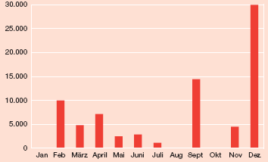

*Figure 4*: traded amount of carbon 2009

In the current trading period, which started on April the 1st, participants cannot use the certificates from the first period anymore. Since 2008 there are no more entry fees for being able to participate in the stock exchange. It is intended to make the stock exchange more attractive through this measure.

### Situation in Czech Republic

As we explained the Austrian NAPs in a very detailed way, we will only shortly consider the second NAP of the Czech Republic here. The first draft for the second NAP for the CR was projected in 2006. Originally, the Czech Republic demanded for a number of 101 900 000 allocations per year. After a decision of the European Court of Justice, 15 000 000 were not permitted and a number of 86 835 264 allowances per year remained. The plan says, that 1 20 mio. allowances of that number are kept as a reserve for new participants and 99 389 shall be used for projects of Joint Implementation.

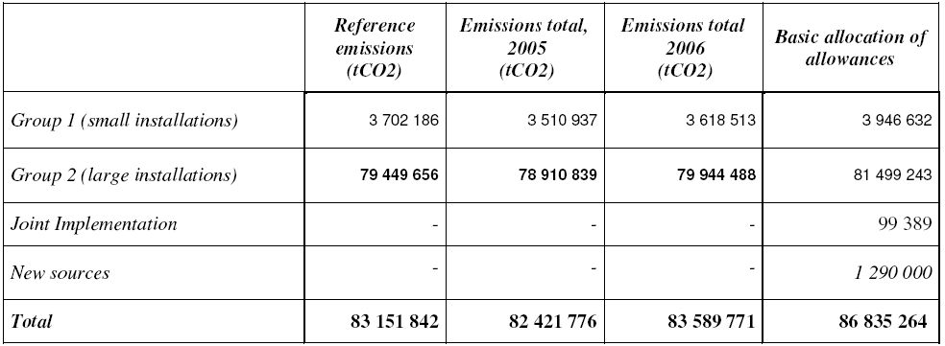In comparison to the Austrian allocations, the concerned industries are not apportioned by sector but by amount of emissions. Therefore two groups are built: The first one stands for installations, which emit less than 50 000 tones of carbon per year and is denoted as “small installations”, whereas the “large installations” refer to installations, which emit more than 50 000 tones of carbon per year. The number and distribution of allowances is shown in *figure 5*.

*Figure 5*: Number of Allowances for 2008 – 2012 by groups

All allocations are distributed for free and the allocations can be transferred to the next trading periods. In comparison to Austria, there is no possibility to trade allowances by stock exchange. The whole paragraph is referring to the second NAP of Czech Republic.

## Comparison of energy mix in Czech Republic and Austria

This section provides a comparison of energy industry in Czech Republic and Austria with particular focus on how this sector contributes to general level of national emission. It is absolutely crucial to make this kind of comparison if we want to proceed further in our analysis of the overall impact of EU ETS on Austria and Czech Republic.

Before we step up to main comparison of power sector and its contribution to national emission in each country we need to briefly discuss the differences in total emission. GDP of Austria is approximately twice bigger then Czech and GDP per capita is even bigger because Czech Republic has nearly ¼ more inhabitants.[1] On figure bellow CO2 emission per capita is depicted CO2 of both countries, and since there is more people in Czech Republic it is obvious that on overall level Czech Republic emits lot more than Austria. To be more specific, it emits annually almost twice as much carbon emission. (*World databank*)

*Figure 6:* Comparison CO2 per capita 1992-2007

It will not be an exaggeration to say that these differences in CO2 levels can be directly linked to different energy structure and fuel dependence. Two figures below compare the contribution of power sector to total emissions in 2007; it is clear that in Czech Republic this particular sector contributes to majority of CO2 emission in comparison with Austria, where it is only one in the row. The table below sheds light on the main reason of this fact. As we can see, Czech Republic produced three times more primary energy in 2008 than Austria (part of that is exported, as a Czech Republic is net exporter of electric energy), but share of fuel to total energy production and energy mix is unparallel between these two countries. Austrian energy mix with 78 % share of RES (especially biomass and hydro power) is not only outstanding within middle Europe, but within Europe in general. (*EU energy and transport in figures, 2010*) The Czech energy mix with major share of lignite fuel and hard coal (or solid fuels in general) is on the other hand mainly the inheritance of previous era of centrally-planned economy with a large degree of monopolization in sector, which was characterized by a lag in technology development and high energy use.

In this aspect, there is one indicator that especially predicates and it is energy intensity. It basically means, how much energy is needed to produce one unit of GDP. As we can see in *Figure 2*: *Energy intensity, AT and CZ* (in appendix) Czech Republic needs almost fivefold energy output to produce unit of GDP than Austria which is approximately on the average of EU-25. This indicator is very complex and it adverts not only to particular price setting and market structure of energy sector, but to overall energy efficiency. It refers to a) higher energy dissipation along the way to final energy usage in production b) overall efficiency of energy usage in production. As EU ETS is arranged to influence only the biggest CO2 emitters, it happened that there is a slight disproportion between relative share of particular sector on total emission and its share in EU ETS. Figures bellow depicts a development of verified emission of Czech Republic and Austria from 2005 to 2010 (red line splits first and second trading phase). Very important is to compare the share of combustion installation which mainly consists of energy producers and trends in emission which in case of both countries supports the contentions that EU ETS fails in its aim.

*Figure 7*: Verified emission - Czech Republic, 2005-2010

*Figure 8*: Verified emission - Austria, 2005-2010

Based on indicators mentioned above (energy intensity and share of energy sector on total emission) and data of verified emission we can conclude that additionally costs coming from pricing carbon (as a result of EU ETS) will, and probably already did, influence power sector in Czech Republic significantly more than in Austria. In *Figure 9*: *CO2 emission by sector: Czech Republic & Austria* it is shown that Czech power sector emits more emissions and contributes to total emission more compare to Austria.

The overall impact on GDP then crucially depends on cost pass through in price of electricity, but if the price increase would not be approximately fivefold in Austria comparing to Czech (and this relies not only on the amount of emission of particular generator, but on market structure) it is rational to expect much higher effect of EU ETS on energy production in Czech Republic compare to Austria. By the word effect we primarily mean cost pass through and consequent windfall profits. Empirical studies concludes that: “*Windfall profits are highest in countries that have a high level of pass-through of CO2 costs into wholesale power prices, countries with emissions intensive (coal) plant setting the price the majority of the time, and countries that allocate the highest percentage of free allowances to the power sector*.” (*Point Carbon Report, 2008*). Czech Republic is more emission intensive and allocates more allowances to power sector than Austria, which strengthen our contention that overall impact resulting in higher cost pass through rates and higher windfall profits will be observable in Czech Republic.

Moreover, it is particularly important to determine, how big is a scope of energy dependency of the second biggest emission emitter – industry sector. Because if industry sector relies heavily on energy as a production input, it is further possible that EU ETS, especially in third “auction phase”, will have a double impact. Cost of CO2 emission will be transmitted directly through allowance price and indirectly through electricity price, this could lead to significant increase of costs in energy intensive industries with particular consequence of loosing competitiveness on markets outside EU ETS. But in this point it needs to be said that in the long run the effect of environmental regulation on competition could be opposite, as the regulation helps to start new wave of innovation process.[2]

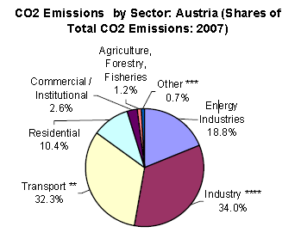But it is very important to say that this conclusion is based on assumption that regulation (and by regulation we mean even economic tool as EU ETS) is imposed symmetrically based on aggregate emission indicators, but as we know in the case of Kyoto or EU ETS allocation targets are set differently among countries using primarily relative emission reduction that is based on particular baseline year.

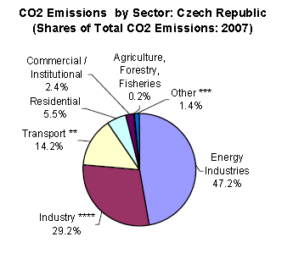

*Figure 9*: CO2 emission by sector: Czech Republic & Austria

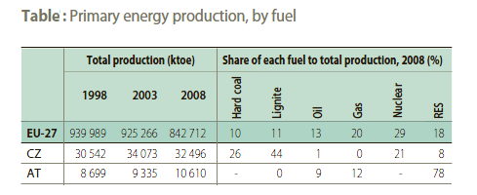

*Figure 10*: Primary energy production, by fuel

Thus it is quite straight forward that even though both countries have almost similar population and area they are incomparable because of different economic situation and historical development in their power sector. Czech development is delayed significantly; the starting point of sector restructuring, oriented to fuel switching and efficiency rising in 1990-ties, came almost 20 years after comparable Austrian development.

So it seems to be a fight of David and Goliath in field of energy intensity and “cleanness” of energy producing units, but crucial question is if they are ever going to meet in one battlefield. Kyoto protocol was constructed to persuade each country to decrease their emission regardless their share on total emission in Europe. And this might be the way how can David not beat (since they do not meet), but keep up with Goliath. Because it is possible to highlight that as aggregate indicators are unparallel, relative successes in emission reduction is more comparable. If we focus on the changes in emission of energy sector only in time period after 1990 we will see that Czechs have been much more “active”. For instance in 1990 the total emission in Czech Republic were close to 190,6 Mt CO2 eq., but as a consequence of transformation it decreased by 25 % within 4 years (in 1997 is was around 150 Mt CO2 eq.), which was pretty remarkable change. (*Lovíšková M., 2007*) This decrease was partly connected with fuel switching and overall change in energy sector (see *figure 4*: *Energy dependency – hard coal and derivatives*). On the other hand, development in Austria was different, from 1990 total emissions were growing and it hit 91 Mt CO2 eq. in 2004 (*ibid*), from then till the end of first phase of EU ETS in 2007 the increasing emission trend is still present (see *Figure 5*: *GHG emission trend;* in appendix).

## Windfall profits as an impact of carbon trading

As we will further show, there is a correlation between price and generally allocation of allowances and energy price. Increase of energy price was one of the main consequences of the beginning of EU ETS program. There was lot of confusion especially among energy consumers particularly from energy intensive sector such as primary aluminum production if the welfare relocation was contrived intention of the trading system. Opponents of the system referred to the issue when energy companies raised their profits using allowance allocation as an excuse even before the beginning of the main program (*Schmidt, Vance & Frondel 2008*). One of particular question was how is it possible that energy companies are transferring their costs on consumers even though they in stage of grandfathered allocation obtain all of the allowances for free (in case they are able to cover their emissions form allocation). One of the answers which were put forward was the idea that cost relocation is caused by specific industry organization in power sector, concretely lack of competition.

But this kind of reasoning is inherently false. Firstly, it is important to say that passing through the allowance value (costs) to energy price is perfectly reasonable action in accordance with functioning of market economy. Even though allowances are grandfathered they are basic example of opportunity cost. In other words every used allowance is implicitly forgiven revenue for given company, and as such it is reasonable and economically rational to include it into price. “*Hence, for a company using an emission allowance, this represents an opportunity cost, regardless of whether the allowances are allocated free or purchased at an auction or market.*” (*Sijm, Neuhoff & Chen 2006*). As long as certificates are traded on stock exchanges the profit of one MWh need to cover not only costs of production but opportunity costs of unsold certificates as well, if not, it would be rational to stop producing and rather sell allocated allowances. “*In a more liberalized power system, the combined opportunity costs of fuel and CO2 for the marginal generator must exceed the power price, if the system is to have a sufficient level of generation to meet demand. If the power price does not exceed these short-run marginal costs, then it would be more profitable for the marginal generator to sell the fuel and the CO2 allowance than to generate.*” (*Point Carbon Report 2008*)

Other note must be done concerning the structure of power market. Even though it is straight forward that energy market is not to close to perfect market structure, it is essential to emphasize that in this particular case the passing through scenario is possible because of demand structure rather than market structure. Sijm et. al. (*2009*) for example distinguish three main factors which influences cost pass through rate and thus simultaneously amount of wind fall profits: (1) the number of firms active in the market indicating the level of market concentration (i.e. if the market structure is monopolistic, duopolistic, oligopolistic or competitive), (2) the shape of the demand curve and (3) the shape of the supply curve. So we can see that market structure to some extend influences potential windfall profit, but only along with other factors as a particular shape of demand and supply and as we will see the impact of number of agents in the market i.e. market structure can be rather counterintuitive to common prediction.

Demand for electric energy and for energy in general is inelastic. Concretely for Czech republic elasticity of demand is between – 0,13 – (– 0,26) in short run and – 0,37 – (– 0,46) in long run.[3] The reason is obvious: it is hard to substitute electric energy. The highly inelastic price demand for energy is mainly caused by no possibility to store the energy as a product which is one of the key characteristic of this market, but this feature does not say anything about market power in particular. Even if there were industry structure with high level of competition, this would not be a guarantee of zero transition to energy price. Surprisingly enough, increase in allowance price could lead to higher price in more competitive markets, in monopolistic structure price is generally higher but the relative increase would be lower. The relation between PTR (pass-through rate) and market structure is particularly interesting and it was shown that it can be somehow counterintuitive.

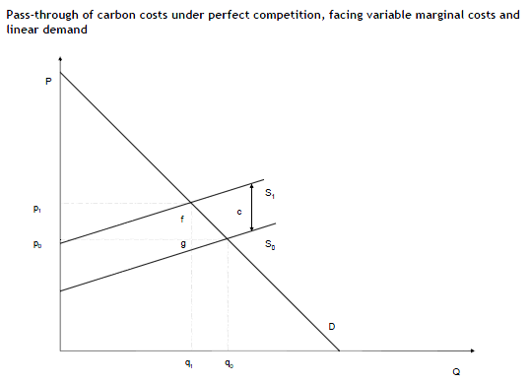

*Figure 11*: Pass-through of carbon costs under perfect competition

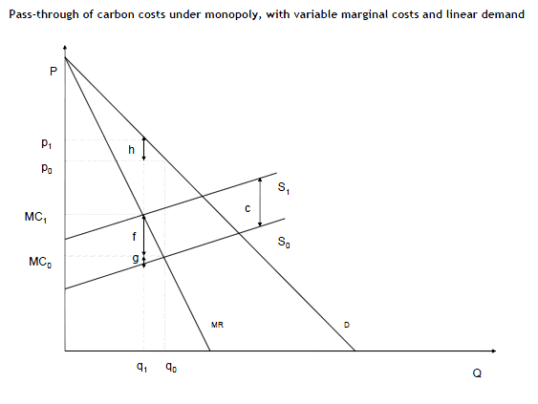

*Figure 12*: Pass-through carbon costs under monopoly

Figures above compares perfect competition and monopoly where the difference between p1 and p2 is the increase in price as an impact of change in marginal cost caused by pricing carbon. Now comes the counterintuitive proposition: Sijm et. al.(2009) demonstrates that with linear downward sloping demand the PTR increases with more competition. With perfectly elastic supply curve the firm in competitive market will be able to transfer full cost to price, while monopolist only half. “*How much the firms will be able to pass the costs depends on market structure and on elasticity of demand and supply. Theoretical analysis shows that firms will be able to pass through 50 % of the costs under the monopoly, and 0-100 % of the costs, depending on the elasticity of supply and demand, under perfect competition. Assuming non-linear demand and supply curves would imply that sectors even pass through more than 100 % of the opportunity costs.*” (*Bruyn, Markowaska & Jong 2010*)

Writing about prices of energy and their increase caused by EU ETS, one fact needs to be mentioned: higher consumer price generally helps to relocate demand towards more renewable recourses and basically serves the main purpose of whole EU ETS, so if we leave aside the main relocation of welfare, it is in accordance with its intended purpose.

On the other hand, in 2012 the second stage will be over and member states will be asked to change their national allocation plans toward new allocation system using auction. Consequently the rightful concern rise with this change and that it is how this rapid cost increase for company influences energy price and energy sector in general.

Lot of papers and studies emerged after beginning of EU ETS tracing the companies with biggest surplus coming from trading and trying to calculate their windfall profits. British firm Sandbag is for example concentrating on biggest producers profiting from EU ETS calling them *fat cats*. Fat cats are called these firms that accumulated remarkable number of unused allowances. In 2008 this agency makes a list of top ten fat cats. The figure below summarizes results. On 8th place we can see a company Čez which along with two other companies E.ON and PRE dominated the Czech power market; all three of them are vertically integrated and act all as both generators and distributors.

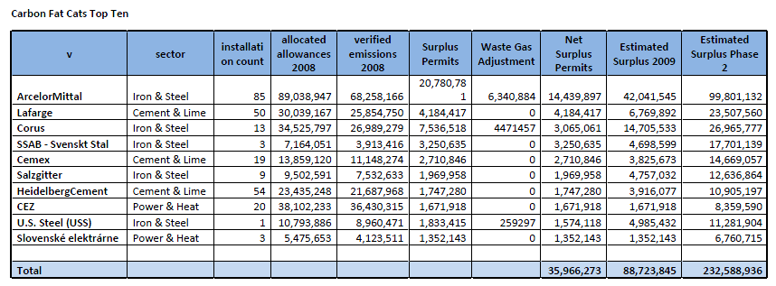

*Figure 13*: Carbon Fat Cats Top Ten

The profit of ČEZ depicted in table is still only part of windfall profit, as we shown above the power generators are able to pass through part of their cost on their consumers. So not only that companies like ČEZ are making profit by selling over-allocated allowances there are possibly transmitting indispensable amount of operating cost through price channel.

Figures below are comparing allocated allowances and verified emission from combustion installations during 2005-2010. In case of Austria there is deficit of allocated allowances on overall level (with exception in years 2007 and 2009) which means that system is set properly persuading emitters to buy what they emits over their allocation. Czech Republic on the other hand clearly allocated too many allowances, which resulted in profits of pure over-allocation. For example in year 2010 in Czech Republic there were 8,7 mil. tones of CO2-equ that was not used by emitters and was thus their net profit, with average EUA price around 15 €/ton it means profits of almost 130 mil. € in total.

*Figure 14*: Allocated allowances and verified emission Austria

*Figure 15*: Allocated allowances and verified emission Czech Republic

## Cost pass through

One of the effects of EU ETS, as we have already mentioned earlier, is the fact that part of a costs connected with allowance (including opportunity cost) is passed through with impact of higher prices of power. PTR generally depends on various facts such as elasticity of demand and supply and particular market structure. Most papers and studies dealing with issue of PTR however provide incomplete analysis of this topic. With theoretical background of industry organization we can formulate a thesis that cost pass through of allowances can differ significantly between peak and off-peak hours. Actual cost of allowance will be transmitted to price almost symmetrically between peak and off peak periods, but fixed cost connected with innovation process which was evoked by trading will be almost completely transmitted to peak hour price.

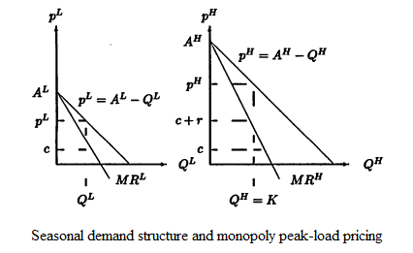

*Figure 16*: Seasonal demand structure and monopoly peak-load pricing

On markets where is a significant change of demand between time periods (and electricity market is surely the case), capacity will be set based on peak operation. The situation is explained on figures above; in peak hours more people demand the product (electricity) and this bigger competition on site of demand allows producer to rise prices including not only operational marginal cost, but even marginal cost connected with capacity (r in the picture). (*Shy, 1996*) If for instance power plant invests in technology decreasing CO2 emission, it will probably mean a decrease of costs connected with CO2 pricing, but fixed cost of innovation will be entirely passed to peak hour price. This situation describes impact of technological innovation, but cost pass through of CO2 allowance, i.e. opportunity cost or actual cost will be passed into prices asymmetrically as well. Figure bellow shows different CO2 cost inclusion into price between peak and off peak. During off peak hours when prices are bid almost down to short run variable marginal costs (SRMC) price includes part of opportunity cost, during peak hours prices include not only opportunity cost, but cost that was really paid (to buy allowances in the market) and fixed innovation cost (*Reinaud J., 2007*). Crucial conclusion from these facts could be that against common fears price progression in third phase do not have to be as rapid as generally expected, since opportunity costs are already included. Particular issue is though how will producers react on fully auctioned allocation, one scenario could be that they include partially in the price their actual costs connected with purchase of allowance and if they used the allowance, they include opportunity cost of forgone possibility to sell allowance on free market as well. In either case - in agreement with theory - price growth will be more rapid in peak hours.

*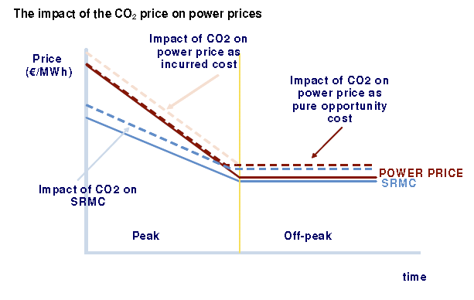Figure 17*: The impact of the CO2 price on power prices

In this context Stadler, Kupzong and Palensky (*2007*) wrote that wholesale electricity price in peak hours are tremendously high (they mention concretely Germany and Austria) and they discus that this fact can be at least partly caused by EU ETS trading.

Two figures below show correlation between EUA price and price of GWh. Even thou both figures have little bit different scale, it is clearly visible that rapid increase of EUA price in April 2010 was closely followed by increase of price for MWh. In May-June period both prices simultaneously hit double top. At the end of the year upward trend occurs again, this time not so rapid in power market.

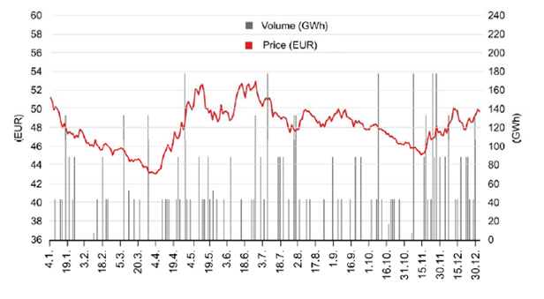

*Figure 18*: Development of energy price in 2010

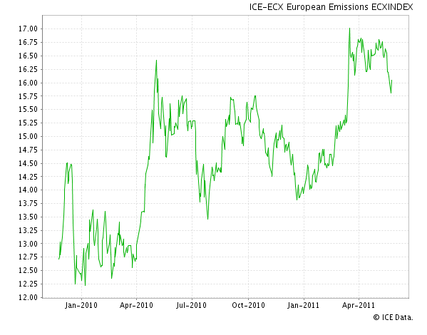

*Figure 19*: Development of EUA price 2010-2011

Even this simple graphical analysis shows that there is a significant relationship between power prices and prices of CO2. Producers react rapidly on significant movement of carbon price.

For further analysis of impact of EU ETS on power market and especially on the market for electricity in Austria and Czech Republic is important to identify marginal unit in both countries. Electricity market is somewhat specific in that way that in certain load period price is affected only by increase of marginal unit. During peak hours the price is created by marginal product of particular generator which decision making relies crucially on development of underlying fuel driver. Pricing between periods thus depends partially on development of price of underlying fuel driver. In Czech Republic the situation is easier to analyze, during peak hours main factor creating price is based on coal fuel driver. In simple words price is set on marginal cost of coal fire power plants. (*Sijm et.al., 2008*). The situation is more difficult in case of Austria; it is very probable that peak price is driven by combined-cycle gas turbine i.e. by gas fuel. But in case of Austria it is very difficult to analyze what role is played by RES. It is highly plausible that underlying fuel driver in peak hours is gas and that RES (probably mainly hydro energy) and its marginal operating cost creates off-peak prices. Underlying fuel driver is again very important for analyzing general CO2 pricing effect. Different fuels and different generation technologies produce very simply different levels of emission, connected opportunity cost differs accordingly. If we take for instance combined-cycle gas turbine it emits approximately 0,48t of CO2 per MWh of electricity, coal power station produces on average 0,85t per MWh. With allowance price around €20/tCO2 it means increase of generation cost for coal plant about €17/MWh and gas plant around 9,6 €/MWh. (*Sijm, Neuhoff & Chen, 2006*).

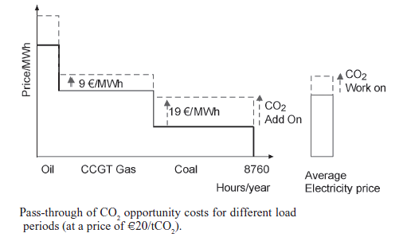

*Figure 20*: Pass-through of CO2 opportunity costs for different load periods

*Figure 20* shows marginal cost duration curve. It is depicted in one graph in descending order, this interpretation is slightly different of what we need, but it clearly shows different increase of marginal costs for different power generators. These facts further strengthen our conclusion about different impact of EU ETS on both countries. The fact that Austria operates on “cleaner” gas turbine plants compared to Czech operating on coal in peak means that Czech producer are transmitting bigger opportunity cost to price.

Sijm et.al. (*2008*) made an analysis calculating PTR, one of the analyzed countries was Czech Republic. *Figure 21* summarize results. Unfortunately whole analysis is not much up to date; it is focused on years 2005 and 2006.

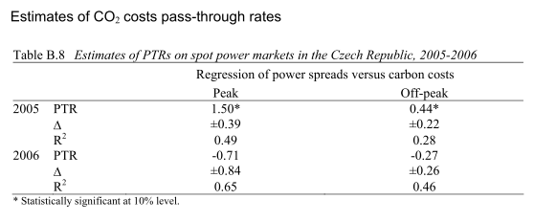

*Figure 21*: Estimates of CO2 costs pass-through rates

Estimation of PTR is based on OLS method using fuel variable (in case of Czech coal) as a control variable, eliminating effects of coal price spikes on PTR. There is however significant chance in PTR between investigated years, in 2006 cost pass through rate was even negative which means negative transmission to power prices.

More elaborate analysis and calculation of PTR for present-day and for Austria is impossible to provide. Usable data are not publicly available and in this particular case it is very difficult to identify fuel driver and gather needed data about it. But in our opinion calculating PTR will be useful for recognition of possible impact of third phase.

## Conclusion

In this work we have analyzed the current situation and results of EU ETS program which will soon enter its third phase. Major changes are expected in this stage, concretely the end of free allocation and beginning of auction system of allowance allocation. Our analysis was based on comparison of Czech Republic and Austria with special focus on impact of EU ETS on power market. In the section focused on the comparison we emphasized how much both countries differ in power production and generally in power market. Based on these information we were able to conclude that development under trading system will be very probably different in both countries, which is strengthened by the summary of structure and the main facts about the trading system. Even though it was not main focus of this work, we had to discus success of a system in first two phases. Development of aggregate emission of agents included in program has not been much in compliance with main aim of the whole program. For example Austria is facing stagnation or even slight increase in emission, Czech Republic was able to reduce CO2 emission significantly, but this was not because of CO2 trading, but mainly because of main revolution of technologies after transformation process. Anyway, six years of a running program do not seem to bring intended results, which is partly caused by over-allocation of allowances. We analyzed progress and results only to that scope that we could compare it with potential cost of a system to analyze whole rationality of it. In this context we discussed a controversial result of EU ETS – windfall profits. Windfall profits are commonly viewed as a negative consequence of trading because of the fact that trading itself enables emitters to gain these additional profits. As we tried to show, this reaction of power producers is completely in agreement with economic theory and if we do not evaluate the consequent utility transfer, it - through the channel of prices - helps to reach main aim of the system motivating to lower use of highly polluting energy sources. We calculated that in case of Czech Republic (where is, in comparison with Austria, much more unused allowances; in Austria in 2010 there was more verified emission compare to allocated allowances) in 2010 that EU ETS was source of aggregate profits of nearly 130 mil € in total in combustion sector. What is more, this profit is only what producers could sell on the EUA market; it did not include the cost pass through in electricity prices. Possibility of increasing prices is another source of profits. PTR is highly complex and depends on vast number of factors, but as we showed, market structure is only one of them and not even the most important one, structure of demand and supply especially their elasticity is on the other hand key factor determining how many costs it is possible to transmit through price channel. Determine future PTR in third phase in advance and then during phase is from our point of view highly important. Unfortunately, the main calculation was because of its complex nature beyond sphere of this work. But we reached the conclusion that calculation of this rate should be made, since auction phase is likely to bring more costs to power producers motivating them to transmit them into price. We had further showed that it could be major difference between increase in prices in peak and off peak hours, important factor could be investment cost which is entirely passed in peak hours. Because of this, third phase of EU ETS can further weaken the competiveness of energy intensive sectors and possibly slow down economic growth. One of the main conclusions in this context is that based on our sources and in the case of probable convergence of targets among states, Czech Republic will be more effected through price channel than Austria, taking into consideration its energy mix and overall situation on power market.

Appendix:

|  |  |  |  |  |  |  |  |
| --- | --- | --- | --- | --- | --- | --- | --- |
|  | | 2005-2007 | | | 2008-2012 | | |
| Country | Kyoto target (% change against base year) | Allocated CO2 allowances (million tonnes per year) | | Share in ETS | Allocated CO2 allowances(million tonnes per year) | | Share in ETS |
| Austria | -13.0% | 33.0 | | 1,4% | 32.3 | | 1.5% |
| Belgium | -7.5% | 62.1 | | 2.7% | 58.0 | | 2.8% |
| Bulgaria | -8.0% | 42.3 | | 1.8% | 42.3% | | 2.0% |
| Cyprus |  | 5.7 | | 0.2% | 5.2 | | 0.3% |
| Czech Republic | -8.8% | 97.6 | | 4.2% | 86.7 | | 4.2% |
| Denmark | 21.0% | 33.5 | | 1.4% | 24.5 | | 1.2% |
| Estonia | -8.0% | 19.0 | | 0.8% | 11.8% | | 0.6% |
| Finland | 0.0% | 45.5 | | 2.0% | 37.6 | | 1.8% |
| France | 0.0% | 156.5 | | 6.8% | 132.0 | | 6.3% |
| Germany | -21.0% | 499 | | 21.7% | 451.5 | | 21.6% |
| Greece | 25.0% | 74.4 | | 3.2% | 68.3 | | 3.3% |
| Hungary | -6.0% | 32.2 | | 1.4% | 19.5 | | 0.9% |
| Ireland | 13.0% | 22.3 | | 1.0% | 22.3 | | 1.1% |
| Italy | -6.5% | 223.1 | | 9.7% | 201.6 | | 9.7% |
| Latvia | -8.0% | 4.6 | | 0.2% | 3.4 | | 0.2% |
| Lithuania | -8.0% | 12.3 | | 0.5% | 8.6 | | 0.4% |
| Luxembourg | -28.0% | 3.4 | | 0.1% | 2.5 | | 0.1% |
| Malta |  | 2.9 | | 0.1% | 2.1 | | 0.2% |
| Netherlands | -6.0% | 95.3 | | 4.1% | 86.3 | | 4.1% |
| Poland | -6.0% | 239.1 | | 10.4% | 205.7 | | 9.9% |
| Portugal | 27.0% | 38.9 | | 1.7% | 34.8 | | 1.7% |
| Romania | -8.0% | 74.8 | | 3.2% | 72.3 | | 3.5% |
| Slovakia | -8.0% | 30.5 | | 1.3% | 32.5 | | 1.6% |
| Slovenia | -8.0% | 8.8 | | 0.4% | 8.3 | | 0.4% |
| Spain | 15.0% | 174.4 | | 7.6% | 152.2 | | 7.3% |
| Sweden | 4.0% | 22.9 | | 1.0% | 22.4 | | 1.1% |
| UK | -12.0% | 245.3 | | 10.7% | 245.6 | | 11.8% |
| Lichtenstein | -8.8% |  | |  | 0.2 | |  |
| Norway | 1.0% |  | |  | 15.0 | |  |
| TOTAL | | | 2298.5 | 100% | | 2086.5 | 100% |

*Figure 1*: ETS allowances per country 2005-2012

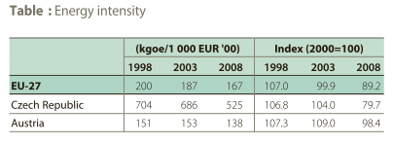

*Figure 2*: Energy intensity, AT and CZ

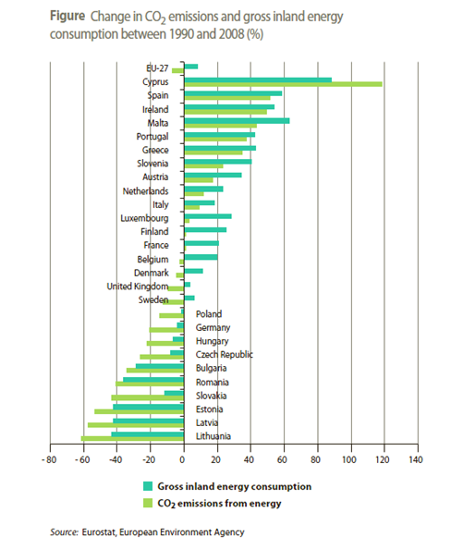

*Figure 3*: Change in emission and gross inland energy production between 1990 and 2008 (%)

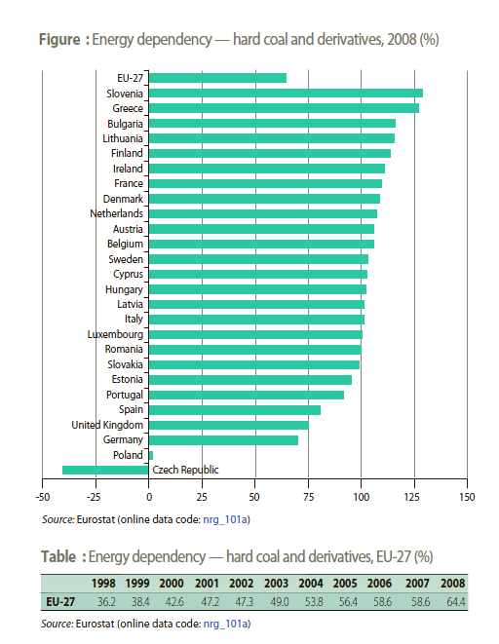

*Figure 4*: Energy dependency – hard coal and derivatives, EU-27 (%)

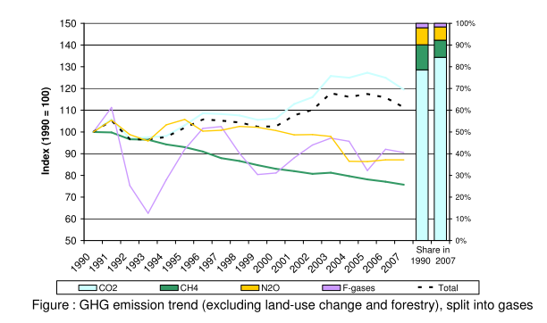

*Figure 5*: GHG emission trend

**Literature:**

BRUYN, Sander de; MARKOWSKA, Agnieszka; JONG, Femke de. 2010, Does the energy intensive industry obtain windfall profits through the EU ETS?: An econometric analysis for products from the refineries, iron and steel and chemical sectors. CE Delft. pp. 1-73. Available from WWW: <www.ce.nl>.

EU energy and transport in figures: Statistical pocketbook 2010, Luxembourg: Publications Office of the European Union, 2010. p. 227 ISBN 978-92-79-13815-7.

GILBERTSON, T., REYES, O. 2010, Globaler Emissionshandel. Frankfurt am Main. *Brandes&Apsel.*

LIST, W. 2009, *Umweltrecht*. Wien. Lexis Nexis.

CAPOOR, Karan; AMBROSI, Philippe. State and Trends of the Carbon Market 2009. The World Bank. May 2009, Washington, D.C., s. 1-71.

SIJM, J.; CHEN, Y; HOBBS, F. 2009, The impact of power market structure on the pass-through of CO2 emissions trading costs to electricity prices – A theoretical approach, *paper presented at the 17th Annual Conference of the European Association of Environmental and Resource Economics* (EAERE), Amsterdam, June 24-27.

EU Commission. 2008, The EU Emission Trading Scheme.

EU ETS Phase II – The potential and scale of windfall profits in the power sector. 2008, *A report for WWF: Point Carbon Advisory Services*. pp. 1-29.

FRONDEL et al, 2008, Emissions Trading: Impact on Electricity Prices and Energy-Intensive Industries, *Ruhr Economic Papers Nr. 81*.

SCHMIDT, Christoph M.; VANCE, Colin; FRONDEL, Manuel. 2008, Emission Trading: Impact on Energy Prices and Energy-Intensive Industries. Ruhr Economic Papers. No. 81, pp. 1-16. ISSN 1864-4872.

SIJM; J., HERS; S.J., LISE; W., WETZELAER; B.J.H.W. The impact of the EU ETS on electricity prices. 2008, *Final report to DG Environment of the European Commission.* ECN: Energy Research Center of Netherlands., ECN-E--08-007, pp. 1-230.

LOVÍŠKOVÁ, Michaela. 2007, European System of Emission Trading: Comparison of Czech Republic and Austria. Diploma thesis: School of Economics, Prag. pp. 1-94.

REINAUD, Julia. (Ed.) CO2 Allowence & Electrity Price Interaction: Impact on industry’s electricity purchasing strategies in Europe. IEA Information Paper. February 2007, 1, pp. 1-85.

STADLER, Michael; KUPZOG, Friederich; PALENSKY, Peter. 2007, Distributed Energy Resources Allocation and Dispatch: An Economic and Technological Perception. *International Journal of Electronic Business Management*, vol. 5, no. 3, pp. 182-196.

SIJM, Jos; NEUHOFF, Karsten; CHEN, Yihsu. 2006, CO2 Cost Pass Through and Windfall Profits in the Power Sector. *CWPE 0639 and EPRG 0617: Working Papers*. pp. 1-31.

SHUTTLEWORTH, Graham; GAMMONS, Sean; HOFER, Paul. Methodology for Measuring CO2 Pass-Through: A Report for EnergieNed. Nera: Economic counsulting. December 2005, 1, pp. 1-26.

EU Parliament. 2003, Guideline 2003/87/EG.

SHY, Oz. 1996, Industrial Organization: Theory and Applications. Massachusetts: The MIT Press, p. 488 ISBN 9780262691796.

PORTER M.E. 1991, America’s Green Strategy. *Scientific American*, vol. 264, no. 4, p. 168.

**Internet sources:**

Climex, Trading emissions, http://www.climex.com/

Czech Statistical Office, ČSÚ, Available from WWW: http://www.czso.cz

Energy, Exchange Austria, http://www.exaa.at/

EU Emission Trading, http://ec.europa.eu/clima/policies/ets/index_en.htm

Federal Ministry of Agriculture, Forestry, Environment and Water Management.(2004) National Allocation Plan for Austria pursuant to Art. 11 of the EZG. http://umwelt.lebensministerium.at

Federal Ministry of Agriculture, Forestry, Environment and Water Management. 2006, National Allocation Plan for Austria pursuant to the Art. 11 of the EZG http://www.omtec.at

Ministry of the Environment of the Czech Repuclic, National Allocation Plan http://www.mzp.cz

World dataBank Available from WWW: http://databank.worldbank.org

**List of figures; sources of figures:**

*Figure 1*: Index of green house emissions in 2008 from the base year and agreed reduction targets according to the Kyoto Protocol for 2008-2012

*Figure 2*: Number of allocations p.a.

Available from WWW: http://www.omtec.at

*Figure 3*: Members of Exaa Emission Certificate Market

Energy Exchange Austria. Available from WWW: http://www.exaa.at

*Figure 4*: traded amount of carbon 2009

Energy Exchange Austria. Available from WWW: http://en.exaa.at

*Figure 5*: Number of Allowances for 2008 – 2012 by groups

NAP Czech Republic. Available from WWW: http://www.mzp.cz/

*Figure 6:* Comparison CO2 per capita 1992-2007

Self made figure – source of used dataset: World dataBank Available from WWW: http://databank.worldbank.org

*Figure 7*: Verified emission - Czech Republic, 2005-2010

Self made figure – source of used dataset: European Union Emissions Trading System (EU ETS) data, *European Environment Agency*. Available from WWW: http://dataservice.eea.europa.eu

*Figure 8*: Verified emission - Austria, 2005-2010

Self made figure – source of used dataset: European Union Emissions Trading System (EU ETS) data, *European Environment Agency*. Available from WWW http://dataservice.eea.europa.eu

*Figure 9*: CO2 emission by sector: Czech Republic & Austria

EU Energy in Figures 2010 : CO2 Emissions by Sector. European Commission : Directorate-General for Energy and Transport. 2010, 1, s. 1-69. Available from WWW: <http://ec.europa.eu>.

*Figure 10*: Primary energy production, by fuel

Energy, transport and environment indicators: Eurostat Pocketbooks. Luxembourg: Publications Office of the European Union, 2011. p. 225 ISBN 978-92-79-16303-6.

*Figure 11*: Pass-through of carbon costs under perfect competition

BRUYN, Sander de; MARKOWSKA, Agnieszka; JONG, Femke de. 2010, Does the energy intensive industry obtain windfall profits through the EU ETS?: An econometric analysis for products from the refineries, iron and steel and chemical sectors. CE Delft. pp. 1-73. Available from WWW: <www.ce.nl>.

*Figure 12*: Pass-through carbon costs under monopoly

BRUYN, Sander de; MARKOWSKA, Agnieszka; JONG, Femke de. 2010, Does the energy intensive industry obtain windfall profits through the EU ETS?: An econometric analysis for products from the refineries, iron and steel and chemical sectors. *CE Delft*. pp. 1-73. Available from WWW: <www.ce.nl>.

*Figure 13*: Carbon Fat Cats Top Ten

The Carbon Rich List: The companies profiting from the EU Emissions Trading Scheme. *Sandbag*. 2010, pp. 1-16. Available from WWW: <http://www.sandbag.org.uk>.

*Figure 14*: Allocated allowances and verified emission Austria

Self made figure – source of used dataset: European Union Emissions Trading System (EU ETS) data, *European Environment Agency*. Available from WWW http://dataservice.eea.europa.eu

*Figure 15*: Allocated allowances and verified emission Czech Republic

Self made figure – source of used dataset: European Union Emissions Trading System (EU ETS) data, *European Environment Agency*. Available from WWW: http://dataservice.eea.europa.eu

*Figure 16*: Seasonal demand structure and monopoly peak-load pricing

SHY, Oz. 1996, Industrial Organization: Theory and Applications. Massachusetts: The MIT Press, p. 488 ISBN 9780262691796.

*Figure 17*: The impact of the CO2 price on power prices Source

EU ETS Phase II – The potential and scale of windfall profits in the power sector. A report for WWF : Point Carbon Advisory Services. March 2008, 1, s. 1-29.

*Figure 18*: Development of energy price in 2010

Power Exchange Central Europe, Annual statistics, Available from WWW: http://www.pxe.cz/

*Figure 19*: Development of EUA price 2010-2011

Intercontinental Exchange (NYSE: ICE); market data: EUA price development

*Figure 20*: Pass-through of CO2 opportunity costs for different load periods

SIJM, Jos; NEUHOFF, Karsten; CHEN, Yihsu. 2006, CO2 Cost Pass Through and Windfall Profits in the Power Sector. *CWPE 0639 and EPRG 0617: Working Papers*. pp. 1-31.

*Figure 21*: Estimates of CO2 costs pass-through rates

SIJM; J., HERS; S.J., LISE; W., WETZELAER; B.J.H.W. The impact of the EU ETS on electricity prices. 2008, *Final report to DG Environment of the European Commission.* ECN: Energy Research Center of Netherlands., ECN-E--08-007, pp. 1-230.

**List of figures in appendix; sources of figures:**

*Figure 1*: ETS allowances per country 2005-2012

*Figure 2*: Energy intensity, AT and CZ

Energy, transport and environment indicators: Eurostat Pocketbooks. Luxembourg: Publications Office of the European Union, 2011. p. 225 ISBN 978-92-79-16303-6.

*Figure 3*: Change in emission and gross inland energy production between 1990 and 2008 (%)

Energy, transport and environment indicators: Eurostat Pocketbooks. Luxembourg: Publications Office of the European Union, 2011. p. 225 ISBN 978-92-79-16303-6.

*Figure 4*: Energy dependency – hard coal and derivatives, EU-27 (%)

Energy, transport and environment indicators: Eurostat Pocketbooks. Luxembourg: Publications Office of the European Union, 2011. p. 225 ISBN 978-92-79-16303-6.

*Figure 5*: GHG emission trend

European Union Emissions Trading System (EU ETS) data, *European Environment Agency*. Available from WWW: http://dataservice.eea.europa.eu

**Abbreviations:**

EU ETS – European Union Emission Trading Scheme

NAP - National Allocation Plan

CER - Certified Emission Reduction

EUA - Emission Unit Allowances

ERU - Emission Reduction Unit

EZG -

MCP - Market clearing price

GDP - Gross Domestic Product

RES – Renewable energy source

AT - Austria

CZ – Czech Republic

PTR – Pass through rate

SRMC - Short run variable marginal costs

1. Source Eurostat, annual data
2. This idea was firstly put forward by Michael E. Porter in his work (*Porter, 1991***)** and it is known as *Porter hypothesis.* The main mechanism indicated by Porter is that environmental regulations induce innovations that are in the end lowering production costs and/or increasing attractiveness of products (*Bruyn, Markowaska & Jong, 2010*).
3. Czech Statistical Office, ČSÚ